Nick McCoy, Pavan Gururaj Muddebihal, Shweta Desai, Ann Xiao, & Dipankar Purohit

DS0 – 545 – Statistical Computing & Data Visualization

World Happiness Report



**Table of Contents**

**Table of Contents………………………………………………………………………………………………………………………………..1**

**Executive Summary…………………………………………………………………………………………………………………………….2**

**Data Description…………………………………………………………………………………………………………………………………3**

**Data Cleaning Techniques……………………………………………………………………………………………………………………4**

**Exploratory Data Analysis……………………………………………………………………………………………………………………5**

**Dashboard: Description, Functions & Screenshots………………………………………………………………………………6**

**Conclusion & Future Work………………………………………………………………………………………………………………….7**

**Appendices & Visuals………………………………………………………………………………………………………………………….8**

**Executive Summary**

**Topic Brief** The World Happiness Report was developed in 2017 and it’s aim was to rank 155 countries across the globe on their happiness. A country’s happiness was determined by economic production, social support and life expectancy to name but a few factors. This research is extremely relevant as the report continues to gain global recognition as governments, organizations and civil society increasingly use happiness indicators to inform their policy-making decisions.

The happiness scores and rankings use data from the Gallup World Poll. The scores are based on answers to the main life evaluation question asked in the poll. This question, known as the Cantril ladder, asks respondents to think of a ladder with the best possible life for them being a 10 and the worst possible life being a 0 and to rate their own current lives on that scale. The scores are from nationally representative samples for the years 2013-2016 and use the Gallup weights to make the estimates representative. The columns following the happiness score estimate the extent to which each of six factors – contribute to making life evaluations higher in each country than they are in Dystopia, a hypothetical country that has values equal to the world’s lowest national averages for each of the six factors listed below:

1. Economic production
2. Social support
3. Life expectancy
4. Freedom
5. Absence of corruption
6. Generosity

**Methods & Intent** In our exploration of relevant data sets and in order to determine which factors may or may not be driving happiness scores forward (or holding them back), our team poured over several sets of data. We explored urban populations as a percentage of a countries total population, enrollment in primary and secondary schools by gender, levels of alcohol consumption, forest area as a percentage of total land area, transparency, accountability and perceived corruption of governments, the percentage of firms with females as the top managers, GDP per capita, government expenditure on education and finally the country’s economic freedom index.

All of this initial data mining effort was done in order to take the surface level findings of the 2017 World Happiness Report one step further, to uncover the drivers and inhibitors of happiness and what we might recommend as a team to policy makers, in an effort to improve their scores, given our findings. It is therefore the aim of this analysis to use various data cleaning techniques, to assist us in our exploratory data analysis, ultimately uncovering interesting insights into a series of questions surrounding the World Happiness Report and the 6 associated factors (listed above).

Our intent is to find empirically driven evidence to support our positions, as well as our strategic recommendations. There are both positive and negative implications associated with a country’s happiness score. On the high end we will aim to discover whether a better score is positively correlated with high per capita GDP and on the low end, our team will look at whether these scores drive people out of the county all together via migration. We will use various cleaning techniques and data visualization tools that will include but are not limited to: graphics, summary statistics, scatter plots, heatmaps and dashboards, complete with descriptions, further analysis and screenshots.

**Data Sets Utilized** We while use the following data sets: 2015 CSV, 2016 CSV & 2017 CSV. Analyzing the following 12 categorical and numerical variables: Country, Region, Happiness Rank, Happiness Score, Standard Error, Economy (GDP per Capita), Family, Health(life expectancy), Freedom, Trust (Government Corruption), Generosity, Dystopia Residual.

**Data Description**

In order to rank the 155 countries according to their happiness score, which is in turn based on the 6 factors below, our team began with the World Happiness Ranking data for 2015, 2016 and 2017. Below is a snapshot of the Top 5 by descending levels of happiness for the year 2015. This data is categorized by both country and region and each associated Happiness Rank.

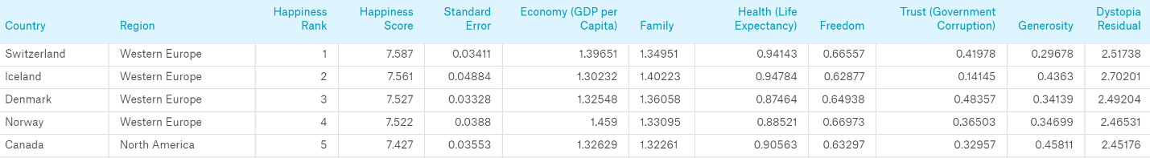

**Exhibit #1**: Top 5 Happiest Countries 2015 (derived from 2015.CSV, World Happiness Report)

This rank is compared to a hypothetical country called “Dystopia” that theoretically has the world’s least happy people. This is useful for our purposes because it provides a benchmark of comparison. Additionally, since life would be very unpleasant in a country with the world’s lowest generosity, least freedom, lowest GDP, lowest life expectancy and least government trust, it is referred to as “Dystopia,” in contrast to Utopia.

**Data Cleaning Techniques**

To begin with, the 3 primary datasets were different. For them to be combined, we first needed to ensure that each of the datasets carried the same variables and same country names. To do so, we started by creating a separate r file named cleanup, which will used for all data cleaning and saving of separated cleaned datasets.

In addition, we created filename WHR, an abbreviation of World Happiness Report. WHR is the segregated list for all the 3 separate datasets –

* + - "World Happiness Report 2015.csv"
    - "World Happiness Report 2016.csv”
    - "World Happiness Report 2017.csv"

There were different nomenclature for parameters in each file. For example, some of the country names listed were different from one year to the next. Such differences would make year over year comparison virtually impossible. As such, we started by making the them same.

Next, the 2017 report did not contain regions, so we made a temporary vlookup function to solve this issue by creating two for loops in r to get the region value from 2015 to match in subsequent years.

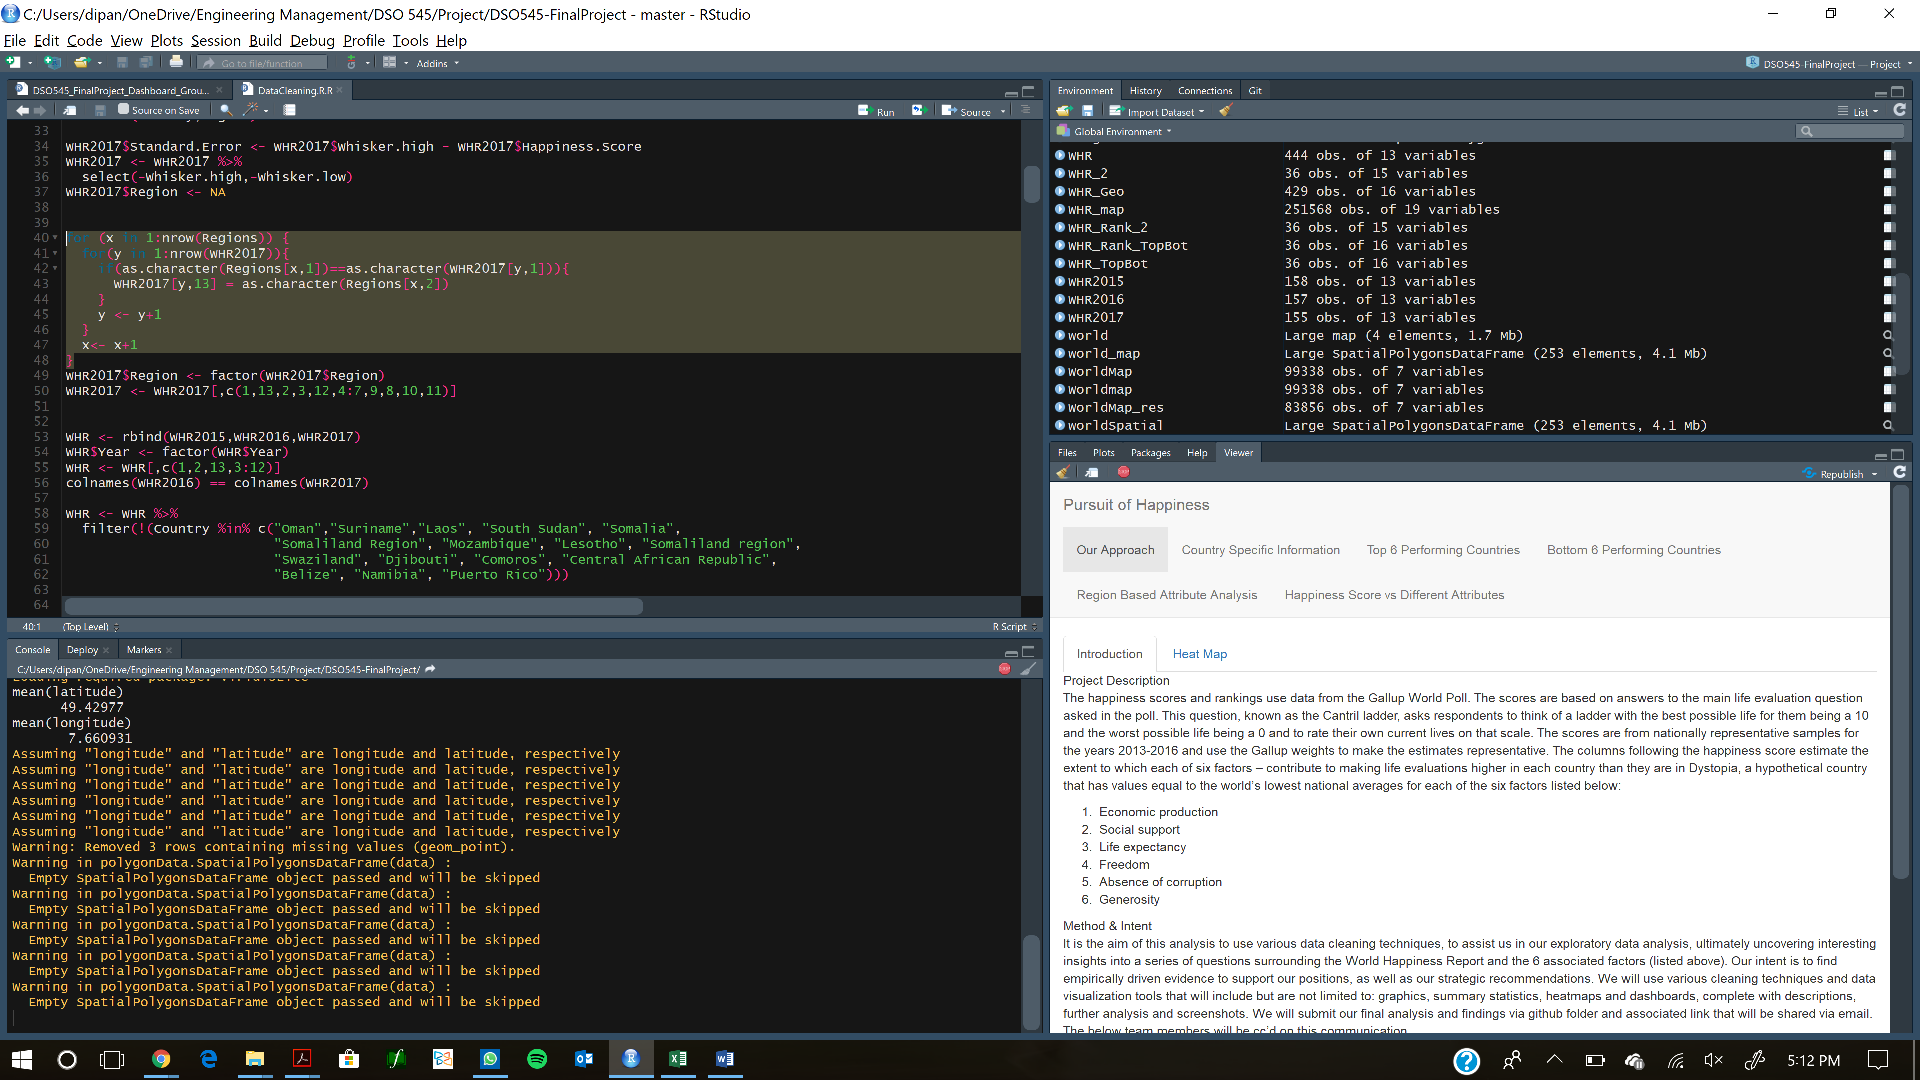

Once the names and regions were consistently labeled across each of the 3 years, we then combine all three datasets into one large dataset using the “rbind” function. Upon further examination we found that some countries were specific to some dataset, so these countries were filtered out. Finally, we saved this dataset in the project directory “WHR.csv”.

Next, we went ahead and created filename "WHR_TopBot.csv". This file was meant to show how the top 6 performing countries (in terms of their associated happiness rank) had changed their attributes from 2015 to 2017. We started by spreading the WHR with respect to year, to calculate the difference in happiness score year over year and between countries. This difference was then saved to a new column “diff”. We then selected the top 6 and bottom 6 countries and commented them with Top 6 and bottom 6. Then both of the above datasets were combined to form WHR_TopBot.

From there we chose to clean and explore a file called EaseOfDoingBusiness.csv which provides a ranking for each country, the higher the score, the higher the ease of doing business in the given country. We created filename “easeofbiz.csv”. Easeofbiz is a subset of file the original EaseOfDoingBusiness.csv. This file also had different parameters based how a country is ranked with respect of ease of doing business. Since we wanted to show a table in shiny with this file, we used Tidy.r to clean the data. We again ran into the issue here where countries were labeled with different names. Hence we used stringr to correct the names of the country. This cleaned file was saved as “easeofbiz.csv”

The next piece of cleaning we attempted was creating the filename “WHR_Geo.csv”. The intention with this exercise was to make an advanced leaflet of our world map, which would interact with different inputs real time. This type of dynamic application is invaluable for user interaction. Early on, we were using mutate_geocode, a function from ggmap, but it was taking more than 10 mins to parse all the data. As such, we created a new file with geocodes already combined to make processing quicker and more efficient. We used package rvest to get latest geocodes from a site. Again, since the names for some countries were different, we used stringr to change them. Then we merged WHR and Geocodes to finally arrive at file WHR_Geo.csv

The next data cleaning technique involved managing a data set that contained more than 99000 rows in this file. We chose to name this filed WorldMap.csv. We saved the world map data from map_data (which is a ggplot function) with “world” as an input. The function map_data is extremely useful as it allows us to easily turn data from the maps package in to a data frame suitable for plotting with ggplot2. In addition, it contains the latitude and longitude of different countries, which allows us to search for and plot very specific locations around the world. Once again, we ran into the challenge of different naming methods for some countries and again we used stringr and some self-thought for loops to correct them. This file was then saved into “WorldMap.csv”

Finally, since we wanted to create some heat maps, hence we needed to combine World map data with WHR. We used merge function to combine both the files. We named this combine file WHR_map.csv.

**Exploratory Data Analysis**

The first data exploration technique that our team employed was the creation of a dual axis scatter plot. A dual-axis scatter plot was created to show the relationship between the score of happiness and the score of the attribute chosen on the aggregate level using the data from all three years, ranked by happiness in descending orders.

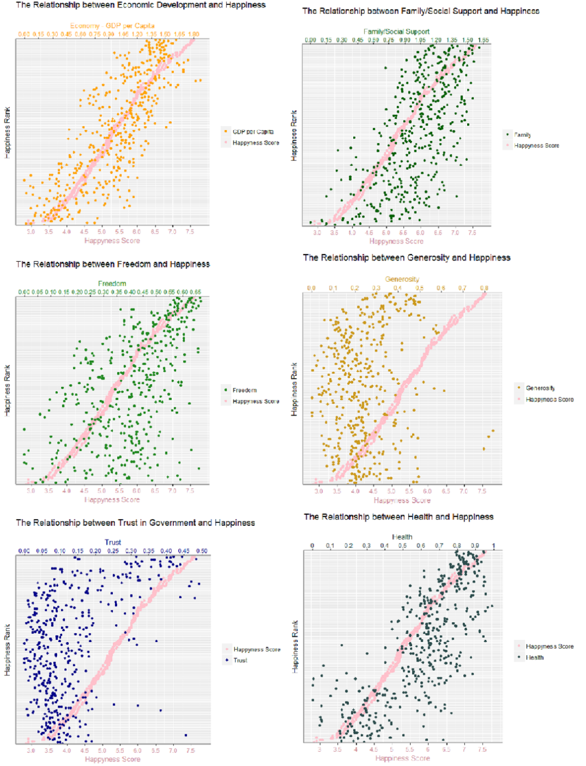

From the charts we can see that although the general tendency is that all 6 attributes have positive correlation with the level of happiness, they distribute differently among countries, their alignment and influence on the happiness level also varies greatly.

Several interesting insights can be derived from the aggregate level based on these charts. For example, in terms of the level of freedom a given country’s people have, if the country leaders and policy makers want to make a very happy country, as is evidenced in top 20, policy makers need to give people high level of freedom; after top 20, there is no specific pattern. For examples in some countries seen below the top 20, we see less clustering and positive correlation in the data as it pertains to happiness and levels of freed. Said differently these countries don’t give citizens much freedom, yet people can have relatively high happiness level.

Another example, the happiest countries are those that, interestingly, don’t exhibit high level of generosity. In fact, the most generous countries are the lower 1/3 in terms of their happiness level.

If looking at trust, you will find that most in countries people don’t trust the government, but in those that the people actually trust the government, their happiness level tend to be very high.

If looking at the bottom right quadrat, we find out almost all attributes have some data points. This implies that neither of these attributes alone can make a happy country and happy people. This is especially true with freedom. The only exception is GDP per capita, which seems to indicate that as long as the economy is good, the people can’t be too unhappy. Economy also exhibits the most aligned trend with happiness with the least variance, which means generally speaking, the wealthier, the happier.

The second data exploration technique that our team utilized was the heatmap. The heatmap is a useful visual aid in simply allowing the consumer of the information to quickly glean insights for countries and regions rather than sifting through a large data set. It also has the dual purpose of allowing the individual to quickly familiarize themselves with the area of the world highlighted. As we have derived in class and our study of spatial statistics, the ability to visualize data and models superimposed with their basic social landmarks and geographic context is invaluable. As such we attempted to create that effect in our dashboard in the following way.

First, we created heatmap based on happiness score for different years 2015-17 utilizing the initial world happiness CSV data. From there, we attempted to merge the WorldMap.csv with WHR to create WHR_map.csv. However, we ran into a challenge. We observed that order was disturbed and produced the following result:

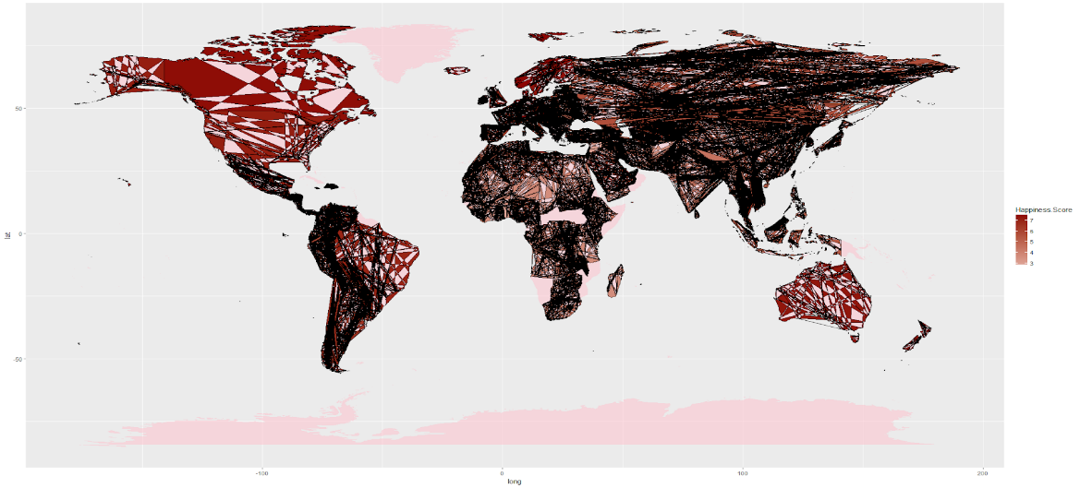

**Exhibit #2:** World Heat Map with Associated Happiness Scores

To solve this, we arranged the order of the countries after grouping the countries. To display the above graph we then used ggplot and Geom_polygon.

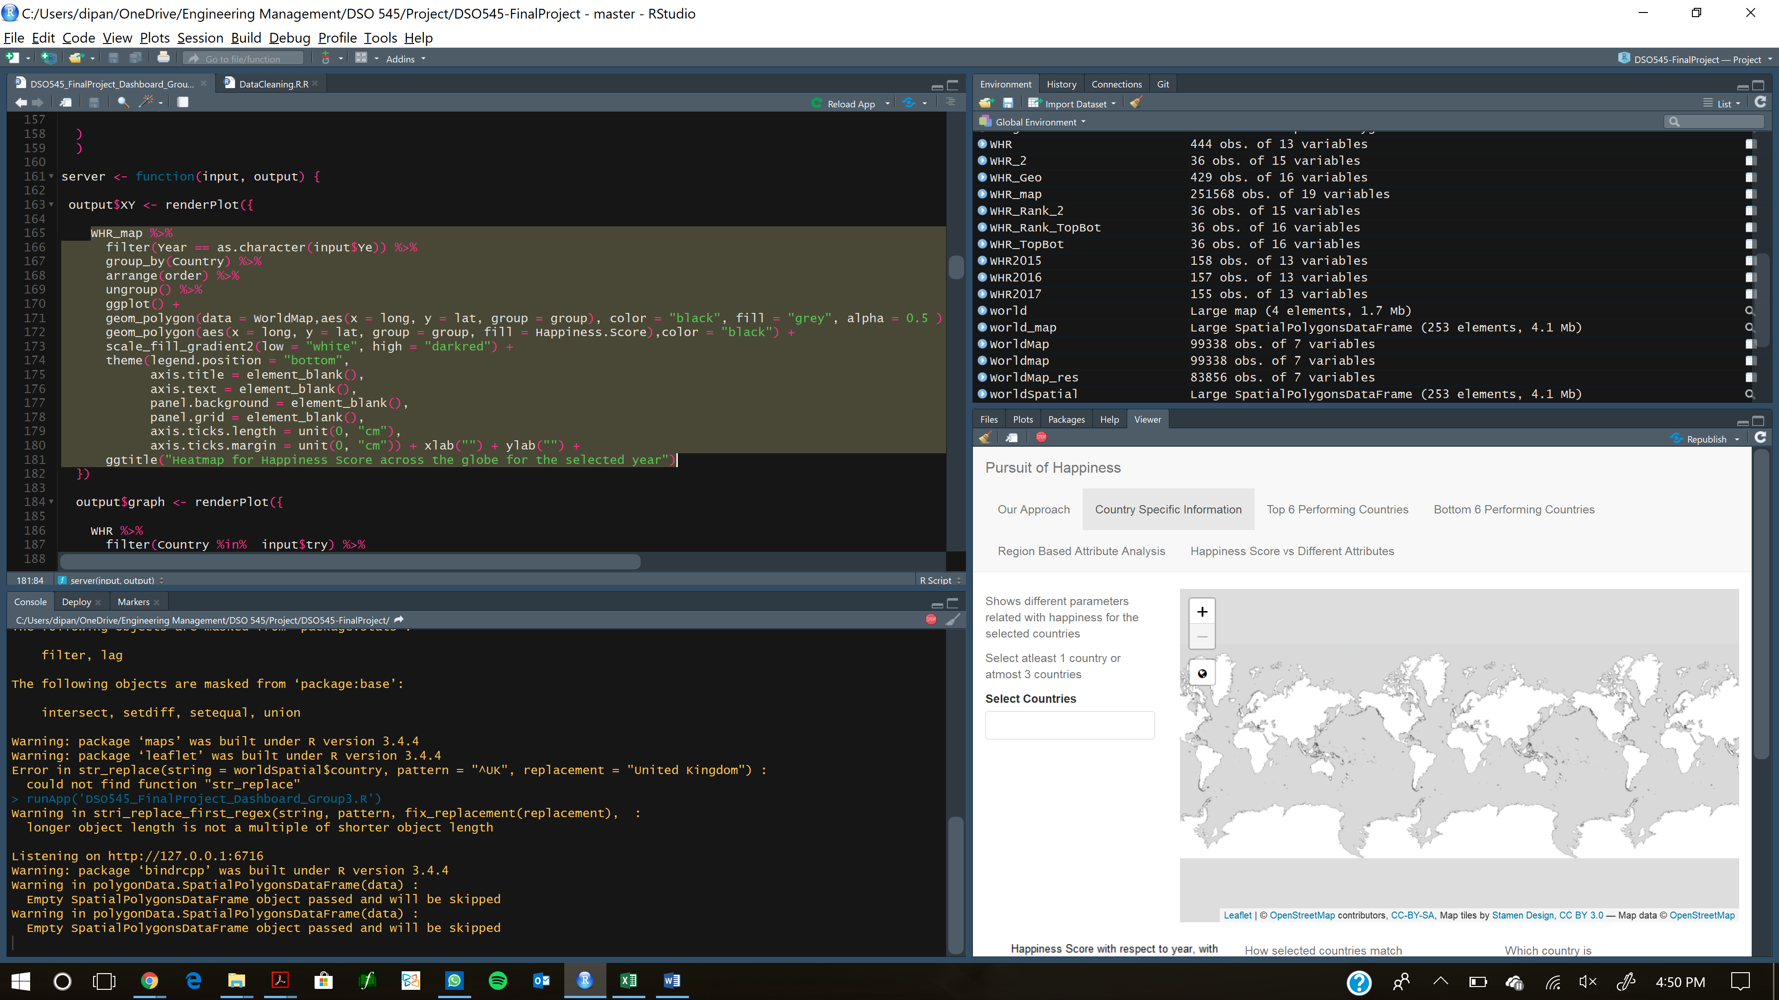

**Exhibit #3**: World Heat Map with Associated Happiness Scores (corrected)

The next functions we aimed to implement in our dashboard were the country specific leaflet, as well as an attribute influence analysis based on region. One of the approaches we took to analyze the happiness score was to evaluate the influence of different attributes on the happiness rank for every region across the 3 years.

The attribute columns estimate the extent to which each of six factors – economic/GDP per capita, life expectancy, freedom, absence of Government corruption, generosity and Family – contribute to making life evaluations higher and that could potentially translate to a higher happiness score. This would enable us to track any changes in the people’s perception towards what drives their overall happiness.

Leaflet library was employed to plot the world map and superimpose different layers showing patterns of influence levels of the six different attributes. User is given the below options via drop down menu

* + - Select Region
    - Select Year

This will allow the user to dynamically choose the attributes and the respective year to visualize the changes in importance of attributes

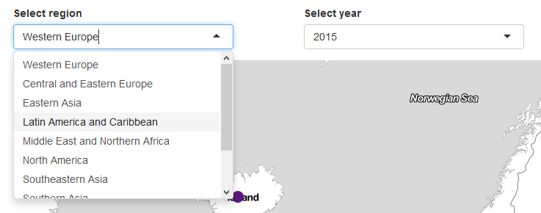

**Exhibit #4:** Country Specific Leaflet: Selecting Region and Year

When the user clicks into the “Select region” drop down menu, this would show the chosen region on the world map with the attribute influence levels for all countries in that region. The map would give a second level of dynamism where user can choose any attribute from the list of six factors for the region and year selected. As is shown below in the bulleted options on the right-hand side of the image.

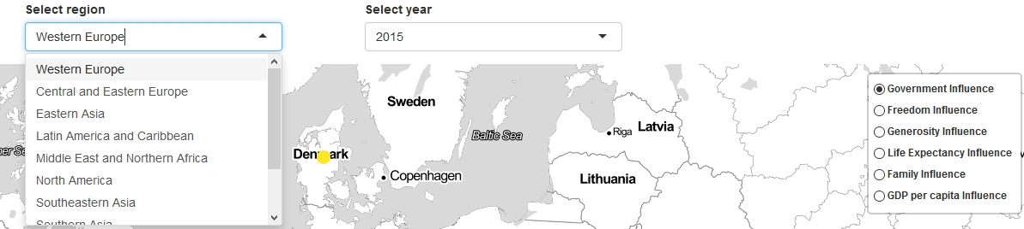

**Exhibit #5:** Country Specific Leaflet: Selecting Region, Year & Attribute

To dive into the second level of dynamism, understanding the level of impact a given attribute has on overall happiness, countries are marked with the colored circles. This marker mapping to the attribute and its level of influence is seen in legend below. For each individual attribute chosen, the map will dynamically change to reflect the color marker for the given level of influence of that attribute.

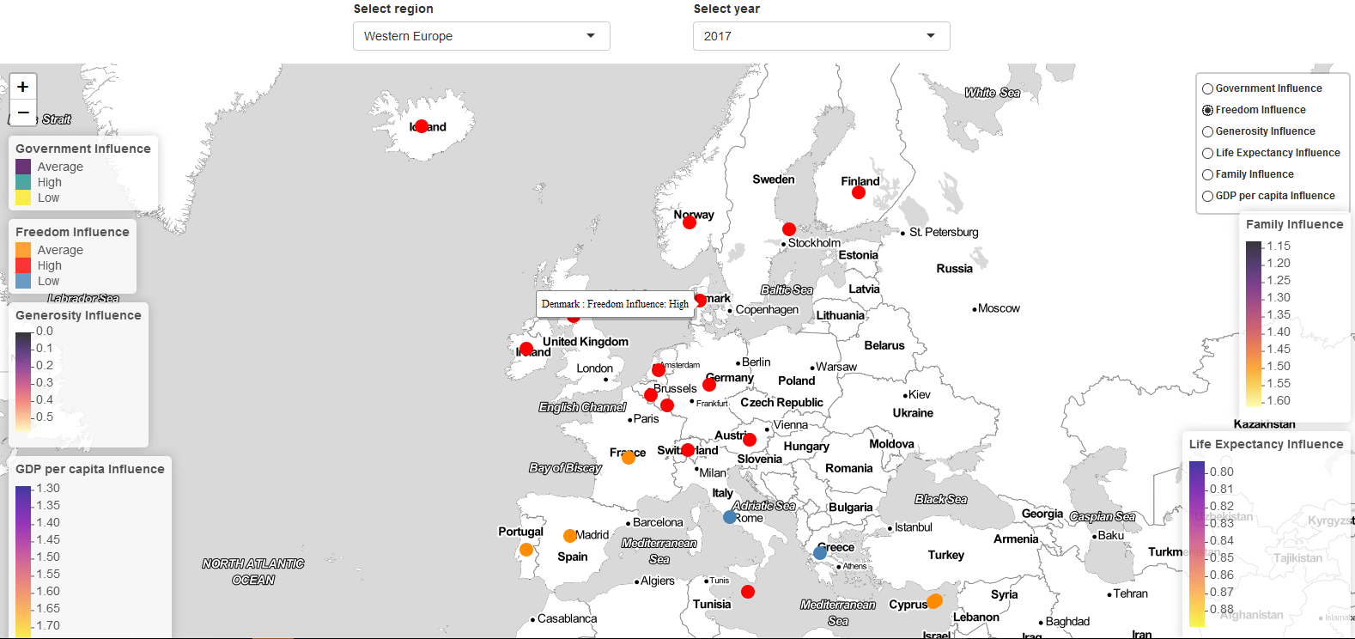

**Exhibit #6:** Western Europe with Attribute Color Markers

In addition, hovering over the country, displays further information such as the country name and attribute influence level metric. For example, the below image displays the influence of freedom for Germany is quite High. In fact, we can see majority of the Western European countries hold freedom to be of high importance to drive their happiness score. Interestingly, this insight also happens to hold true to what we discovered in our dual axis scatter plot of the top 20 happiness scores.

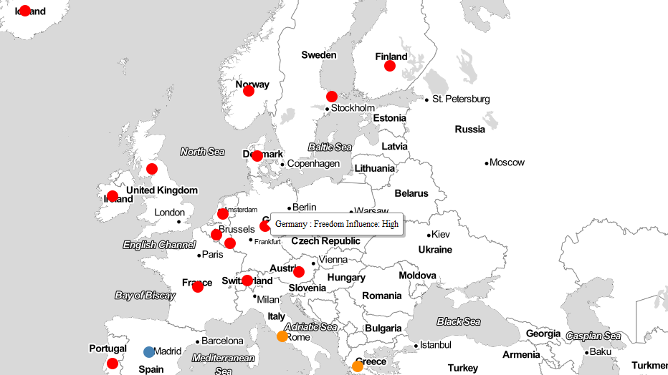

**Exhibit #6a:** Western Europe with Attribute Color Markers (Zoom and focus on Freedom)

Exploring the Freedom influence for Germany and other European countries further for 2016 and 2017, reveals the level of influence is quite consistent and is in the higher range. This can also help conclude that Government and other public policy decision makers, need to take specific actions to ensure the freedom of people is honored for a prosperous living. This is also correlated to Government/corruption situation factor that accounts for a high influence on people’s happiness factor. Thus, the Government would be well suited to carefully craft policies that are transparent and at the same time satisfy the freedom factor as well.

**Dashboard: Description, Functions & Screenshots**

We have utilized almost all available layouts for shiny package to come up with our dashboard. We have used navbarlist as the major interative layout and then used different layouts like navlist, tabset sidebar layout, vertical layout, fluidrow and column layouts weherever required.

We started by introducing our team and a brief introduction of our analysis in the first navbar. We used tabset panels to show introduction and overall change of Happniness Score per year together inside our approach tab.

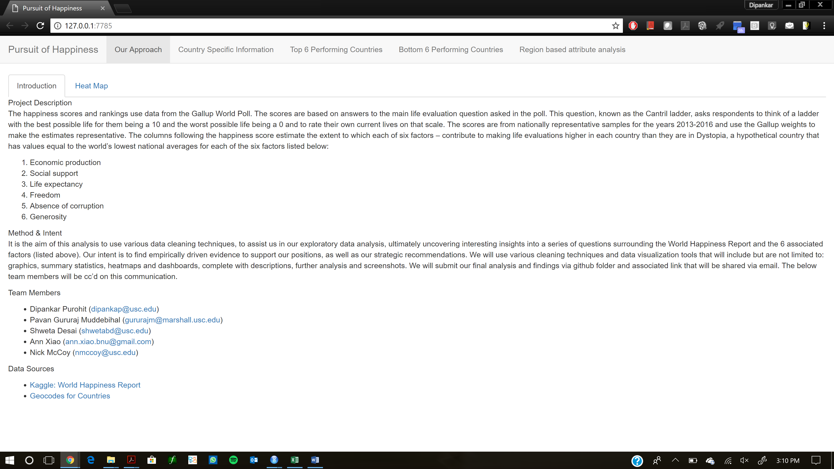

For heatmap the user input will be the year, after selecting the mainpanel will show how the Happiness Score is been changed from year 2015-17.

We can observe that the whole world is getting happier year by year.

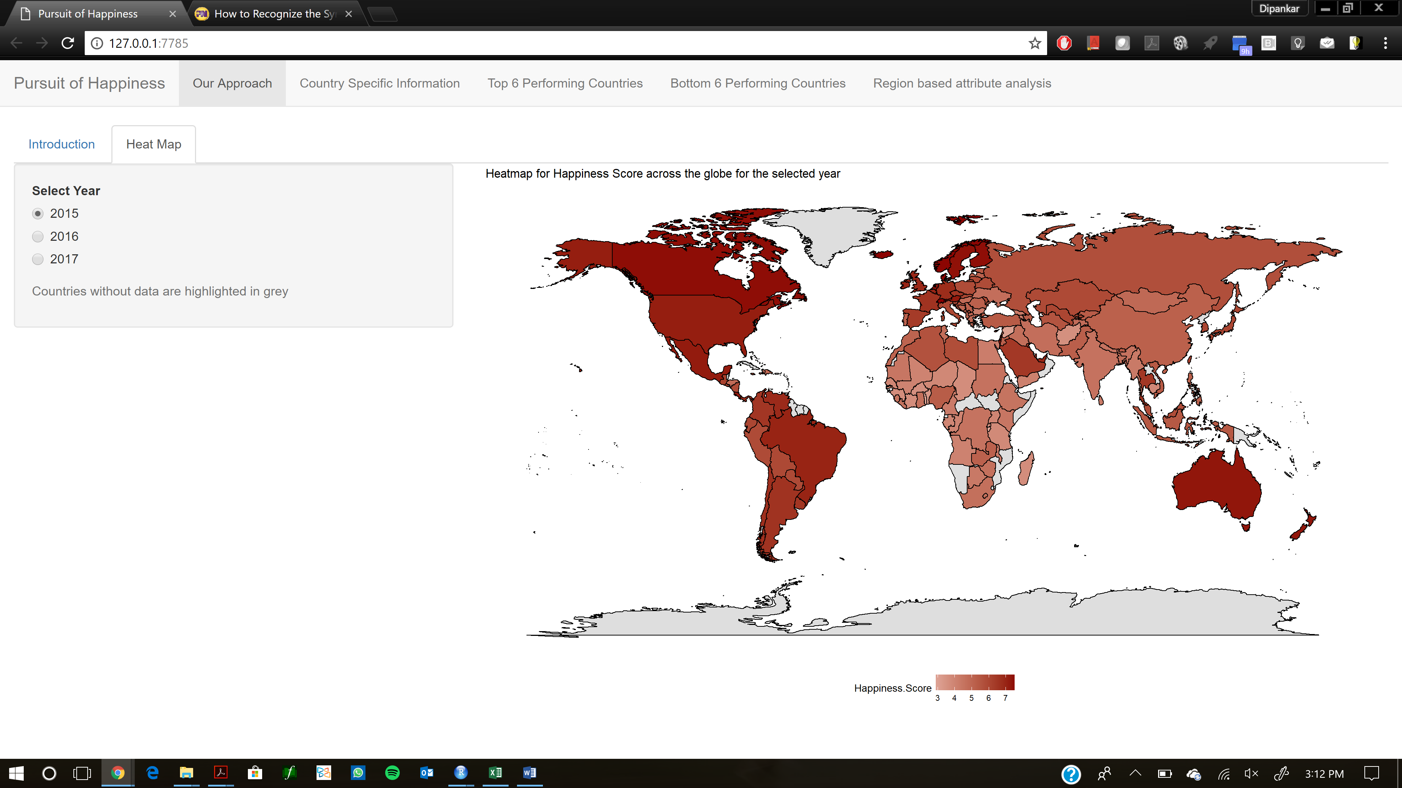

Then we wanted to show Country specific information and comparison among different countries. In this page we will have to select the countries (Max 3, min 1). We can see there location in the world map, how there happiness score has changed in years 2015-17 and there happiness rank for that year.

Furthermore, we can also see the comparative data table, as shown below, which will show the different attribute details. Furthermore, we can see which country is better for starting the business.

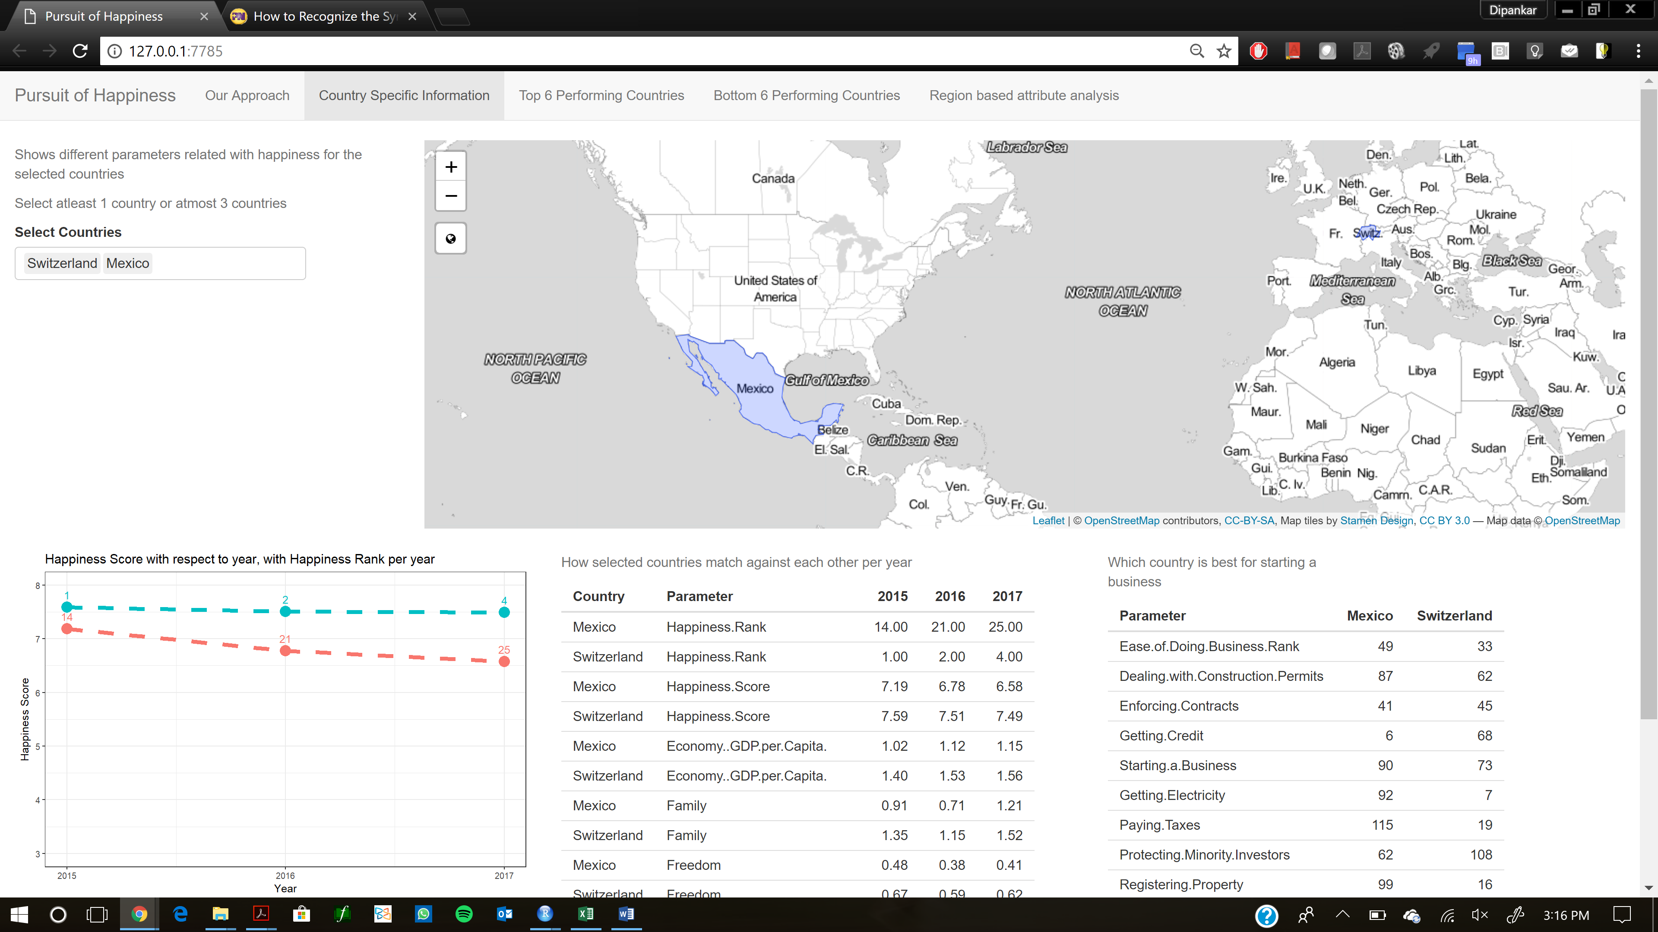

Also we wanted show which countries did best and worst job in the years 2015-17 with respect world happiness. In this tab we can see which companies performed best with respect to other coutries in the world and which countries worked very hard to improve their happiness score from 2015-17.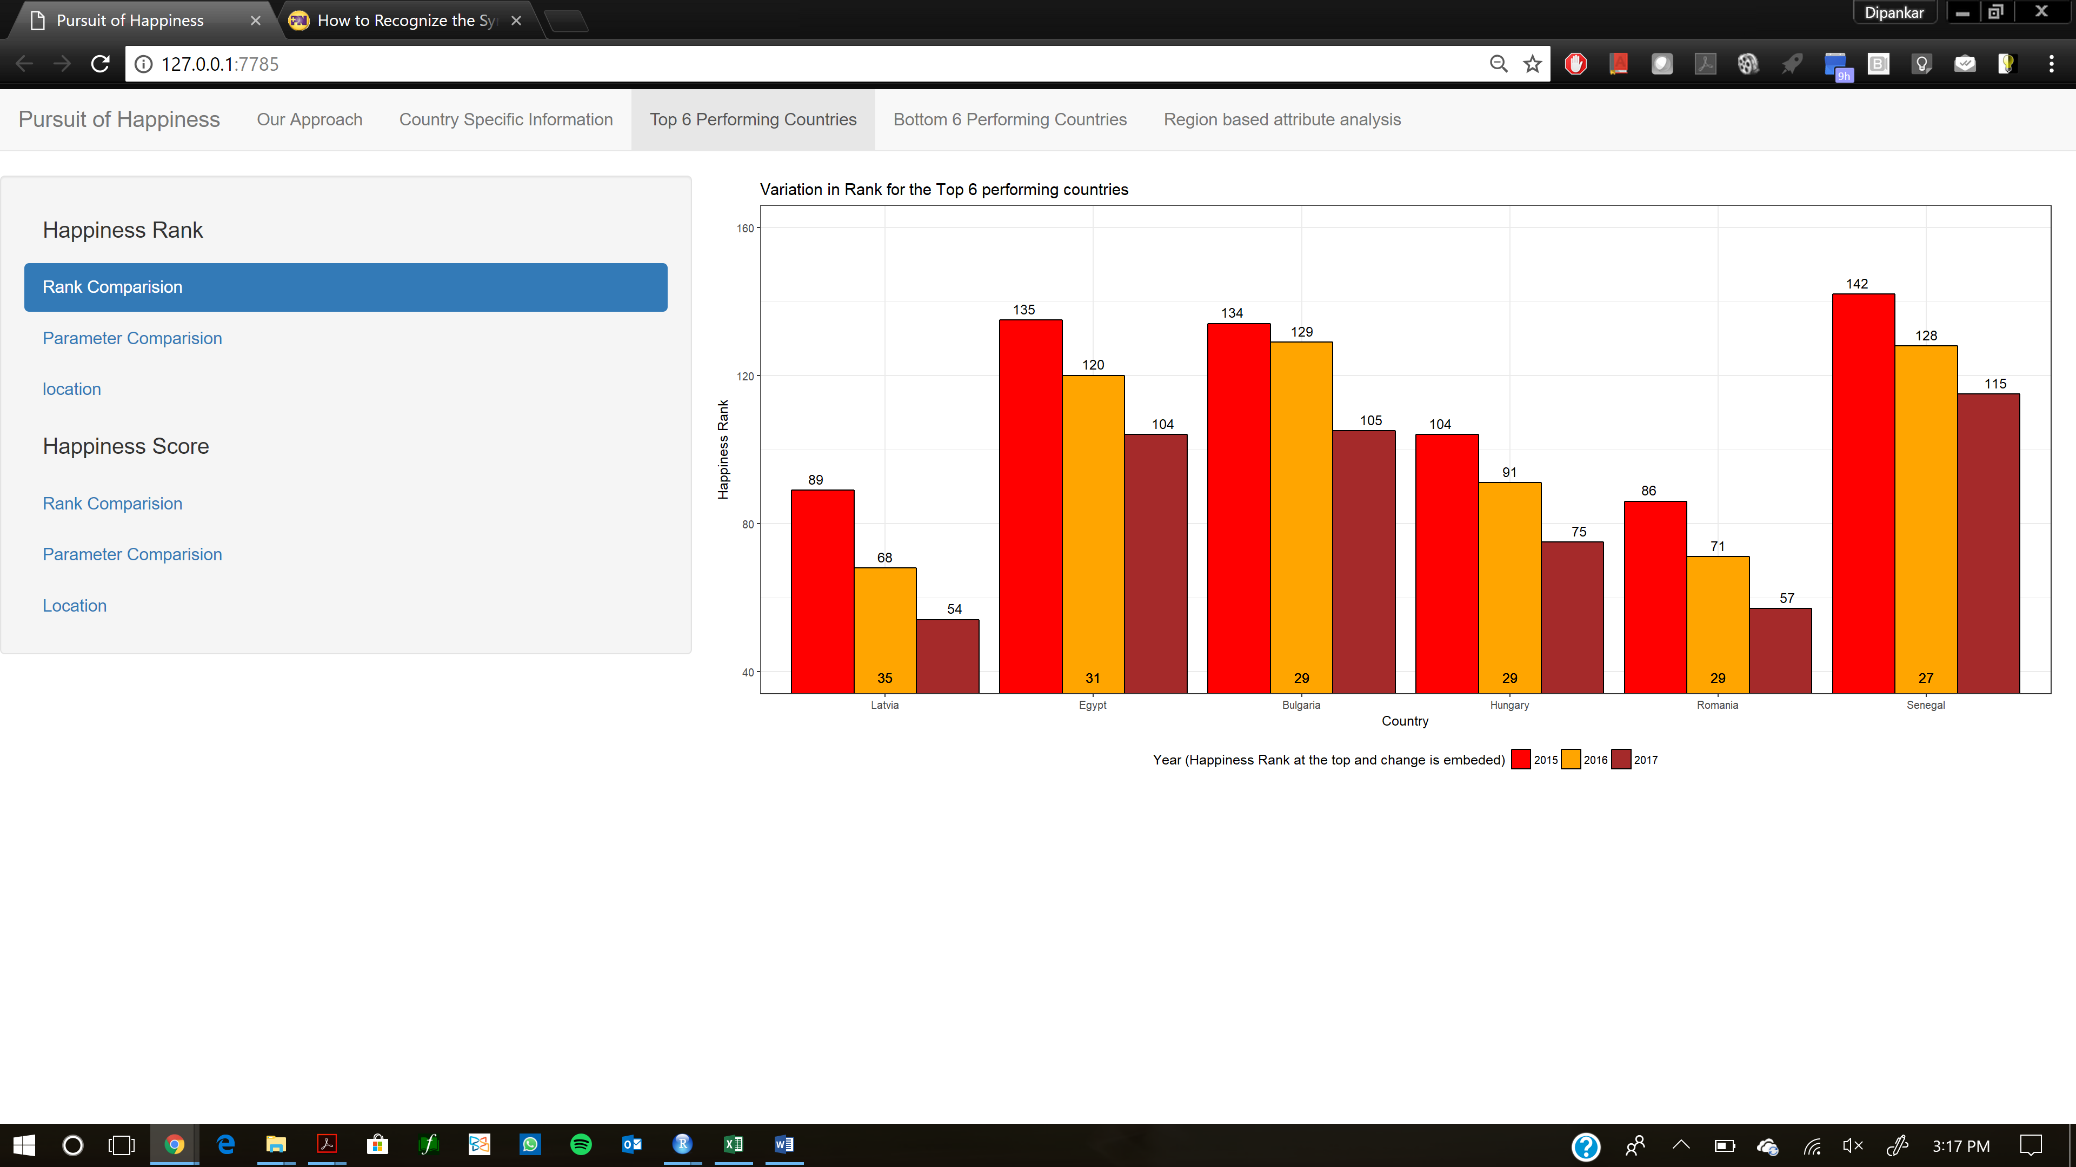

Similarly we showed how the bottom six countries performed with respect to the world and who did worst job in improving there happiness score.

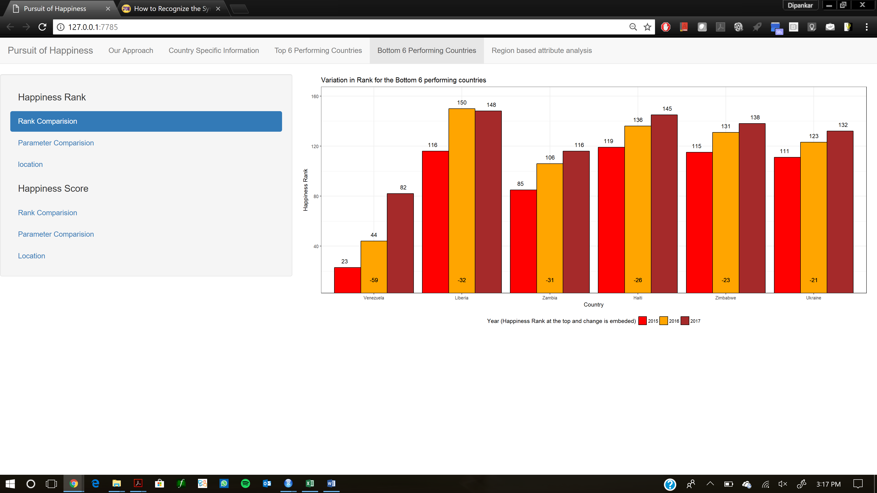

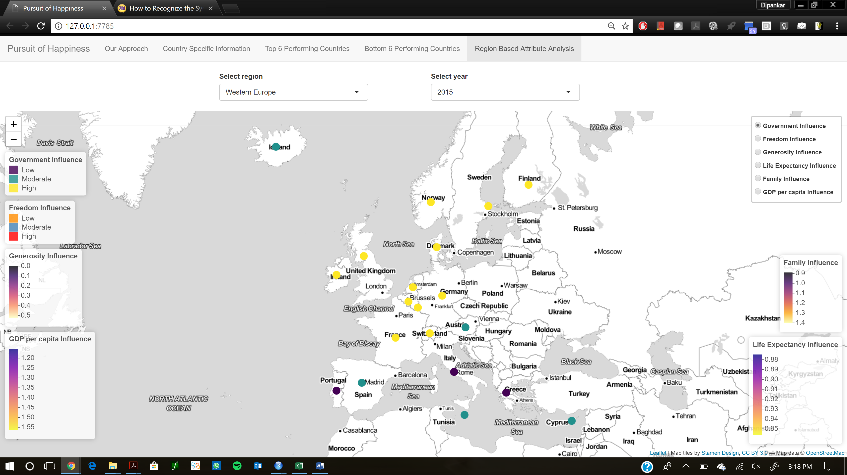

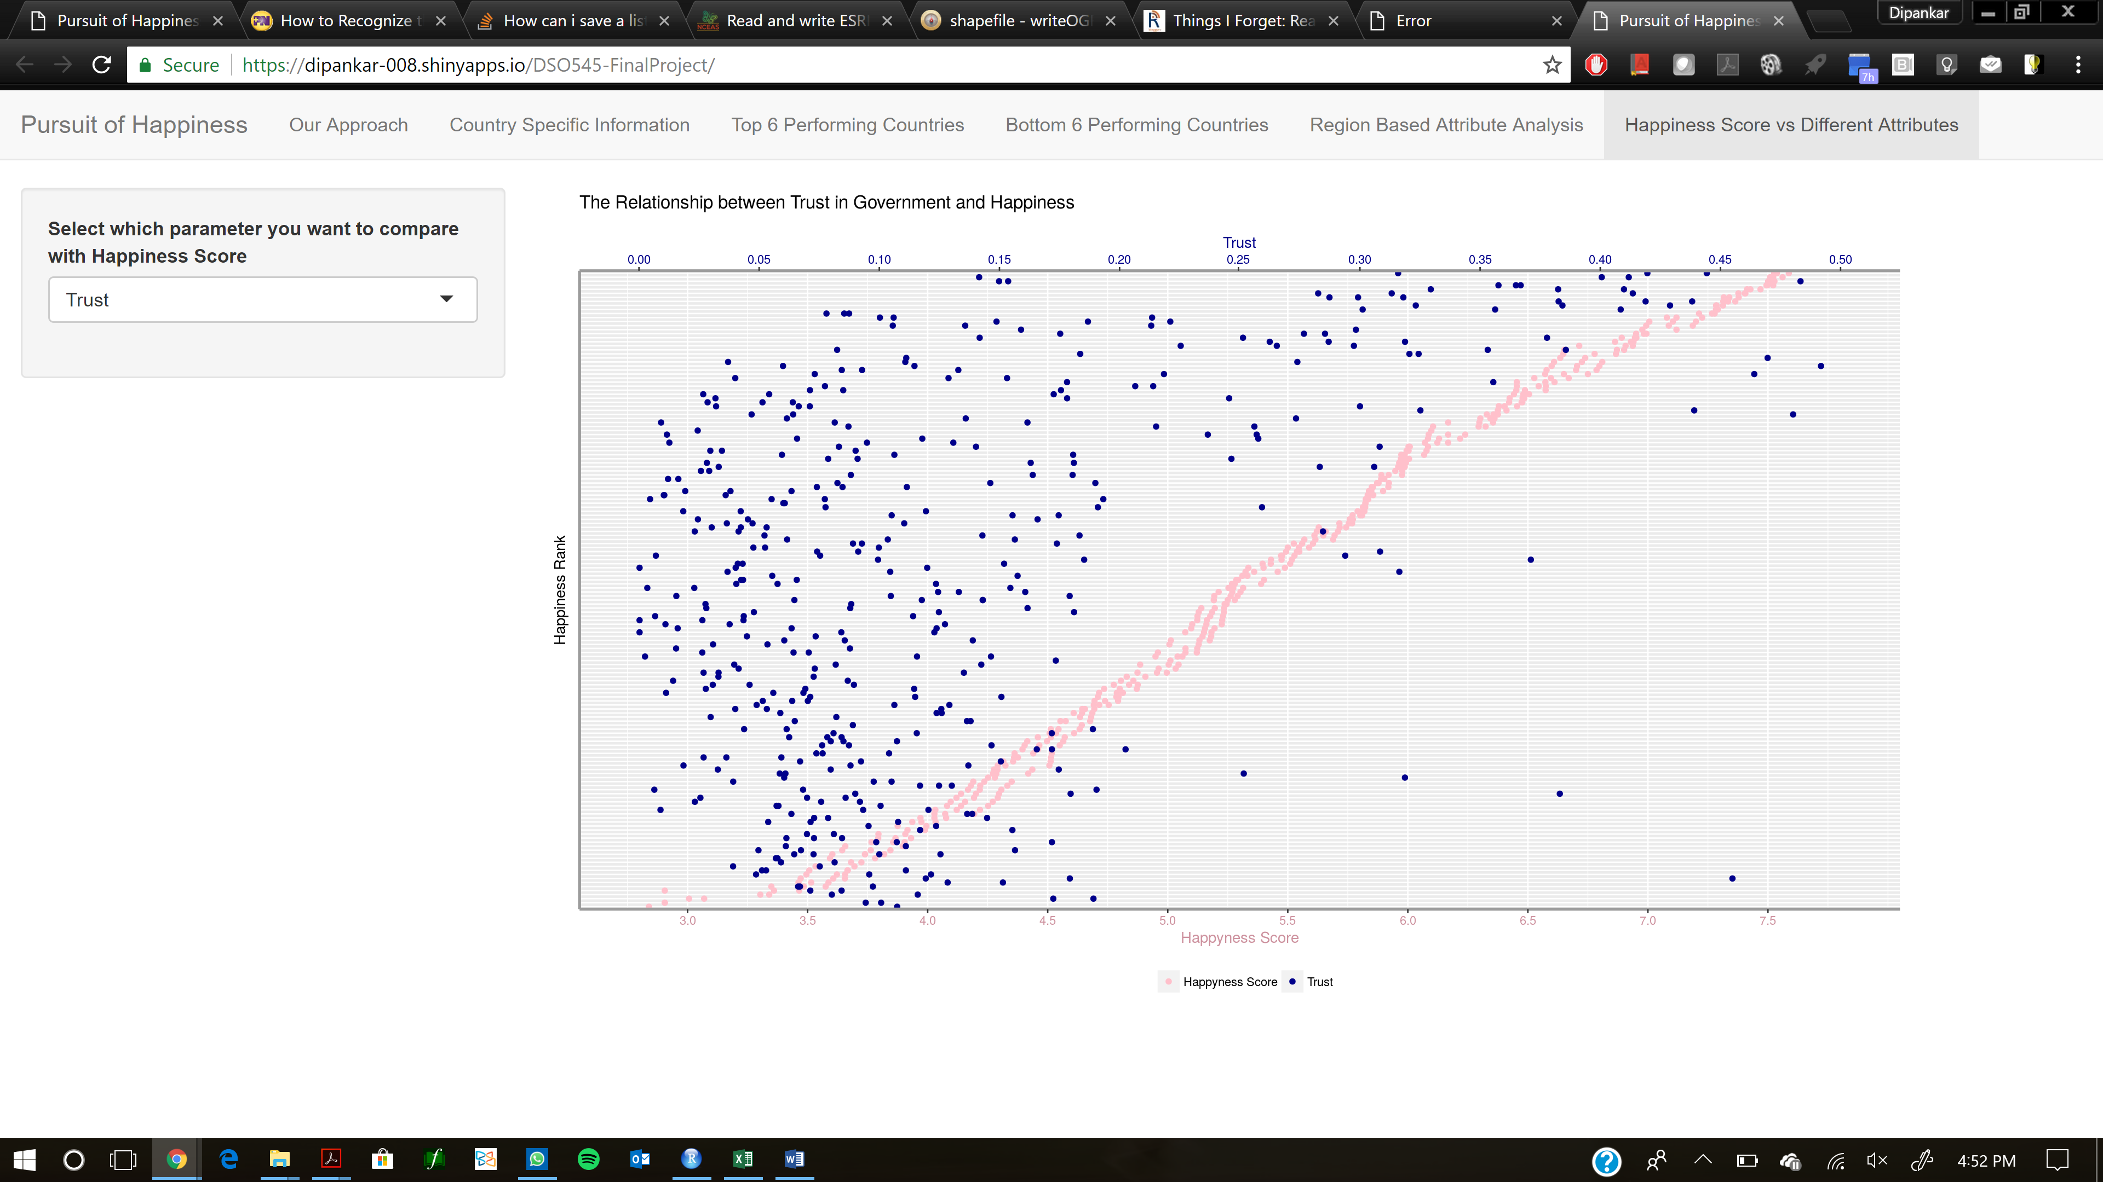

**Conclusion & Future Work**

It is our recommendation based on the data and visualizations presented, that the leadership and policy makers of countries focus on the following few areas if they intend to markedly increase the happiness of their countries and people:

Improving the economic level is the most effective way. It’s a necessary and sufficient condition of leveling up the happiness of their people.

Health and family are also effective areas to focus on, although not as much as GDP. If resources are limited, improving the healthcare of the society and educating the people in core values about family and social support should be prioritized after investment in economic development.

If the country is already relatively happy, and wants to be one of the happiest countries in the world, it can now focus on giving people freedom and building a trustworthy government. But again, these are not sufficient, working only on these attributes doesn’t guarantee a happy country.

【insert time series conclusion --- anything changes with time?】

**Appendices & Visuals**

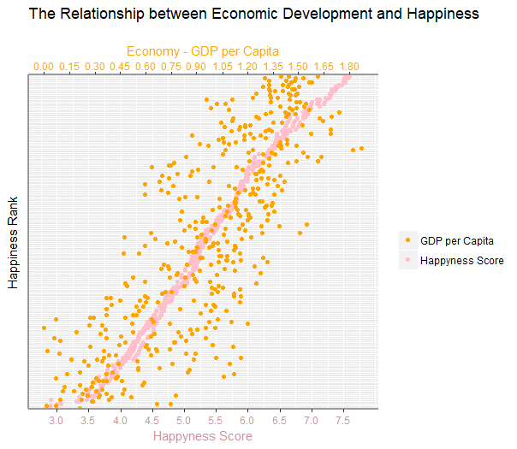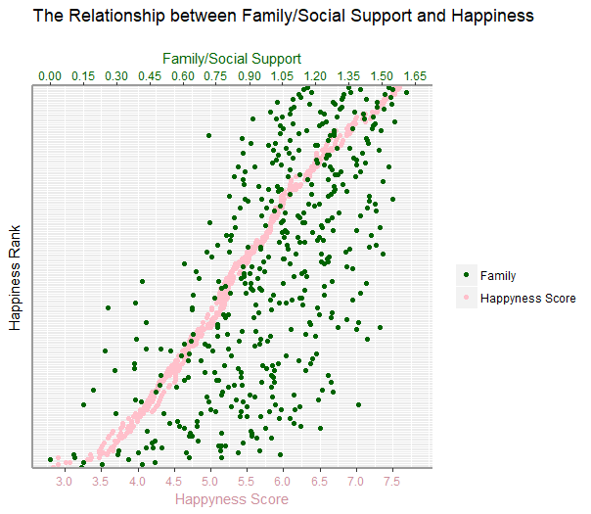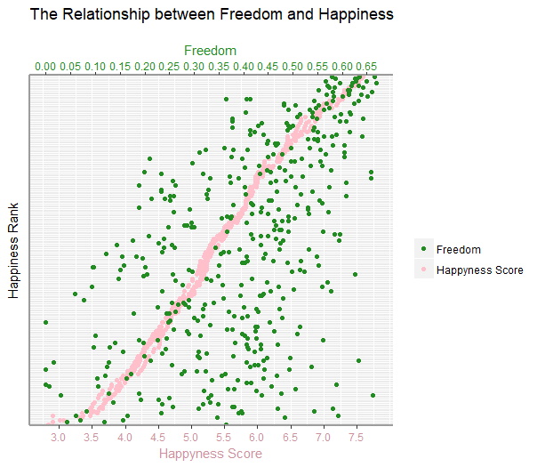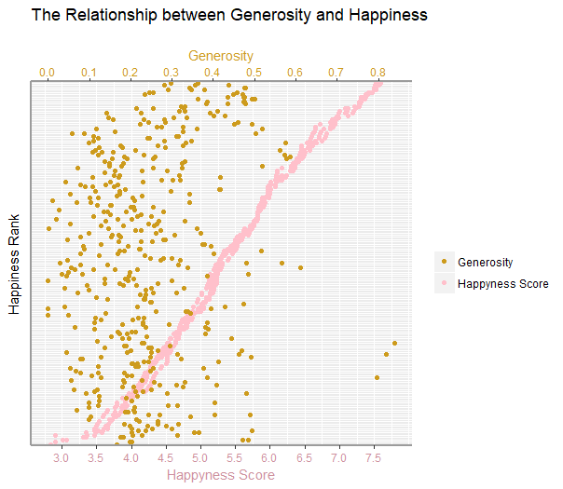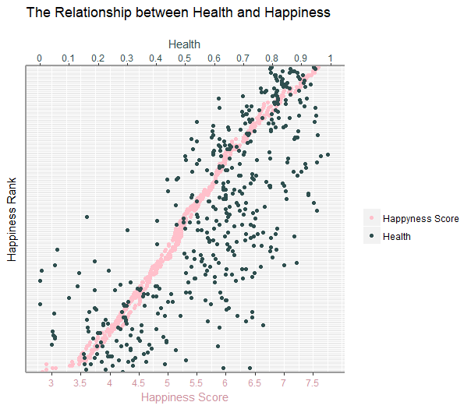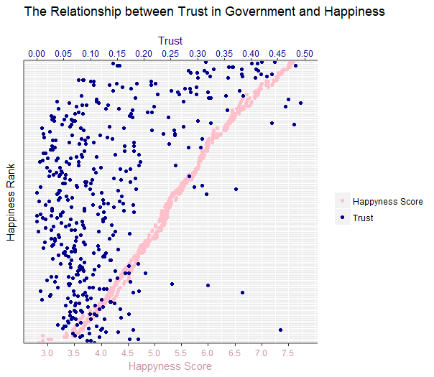

**Region Based happiness attribute analysis**



